**M.E.M.E.I.Q.** - Moderately Educational Memetic Encounters In Quizbowl

A Peter Hotvedt Packet, with help from Maddie B

**Toss Ups With Bonuses (Boni?)**

1. **The earliest sighting of this meme appeared on the Finnish imageboard Ylilauta [ee - la - loo - ta] at 8:45 a.m. EST on November 18th, 2012. The message with this meme showed it, followed by the phrase “this thread is leaking from the heavens” (*)** which then derailed the thread for three days when other users changed the eyes of this meme. This meme has often been used to confused text-to-speech programs as none of the symbols that make it up are technically pronounceable, though some programs pronounce it as “deg-deg”. For ten points, identify this emoticon meme that often used to spam image boards and is alternately known as “Le Face Face”.
   1. **Lenny** Face or **( ͡° ͜ʖ ͡°)** [do not accept Le Face Face, accept description]
2. **Prior to this question being asked, various people shout “blah blah blah” repeatedly. The episode that this meme originates from is widely considered to be one of the best of the series according to redditor Dolphman, and that episode was first aired on September 7th, 2001 and is titled (*)** “Band Geeks”. “Do instruments of torture count?” is the single question that precedes this memetic question, which is asked by Plankton. For ten points, repeat this silly question Patrick Star asks when his band director asks if anyone has played an instrument.
   1. **Is Mayonnaise an Instrument?**
3. **In the U.K. Version of this game, one might notice a political protest message inspired by Matthias Rust involving an airplane. The creator of this game explained that he named this game after a portmanteau of the prefix for four and a sport involving a net and racquets. Playing this game for too long can give you a namesake health condition that makes you see its (*)** pieces while sleeping and in day to day life, which happened to Thor Aackerlund after getting to, and famously clearing, level 30 of the NES version of this game. For ten points, identify this block-stacking game created by Alexey Pajitnov.
   1. **Tetris**
4. **This man’s daughter, a heroin addict, was accused of being white during a city hall meeting, to which this man replied he and his family were proud of their Chicano heritage. In November 2016, it was revealed that this man was undergoing cancer treatment, and got over fifty-thousand dollars on a GoFundMe page within 16 hours. (*)** Before the cataclysmic event that rocked this man’s life, a woman describes him as “pro-bunker”, and this woman later repeats this man’s supposed name while asking “what?”. For ten points, identify this man, who was accused of sexually harassing Zarna Joshi after dad-joking her.
   1. **Hugh Mungus** [accept **Rudy Pantoja**]
5. **Terrible translations of the fourth part of this series included the lines “don’t be dong” and “what a beautiful Duwang”. In the sixth part of this series, a gay priest spins the world so quickly he creates an alternate universe, while in the third part of this series, the main antagonist screams (*)** “ZA WARUDO!” to stop time. The protagonists of the first two parts in this series use a skill known as Ripple, though later on, both heroes and villains alike use abilities known as “Stands” to fight each other. For ten points, name this manga series created by Hirohiko Araki that follows the Joestar lineage.
   1. ***JoJo’s Bizarre Adventure***
6. **In 2009, one user on 4chan’s /b/ board complained that the only threads around were Boxxy threads, hookup threads, report-in threads, and threads about this fact. Unfortunately for some people, using the spacebar results in this action, and instead the key combinations of holding alt and pressing (*)** 255 will prevent this action. In addition, holding alt, and pressing 30 will result in an integral part of preventing this action, creating a triangle unicode text. For ten points, name this action of failing to post three triangles in a pyramidal fashion that newfriends [newfags] do.
   1. **Can’t Triforce** [Be gentle and accept similar variations, prompt on only Triforce.]
7. **Both the red Power Ranger and a nondescript alien are seen in the original video of this action, which was uploaded in February 2013 by a Youtuber whose last name is Miller.** **“Con los terroristas” is the only true lyric in the song that plays during this action, aside from the phrase telling people to do this action. (*)** In order to do this action, one must slowly jive as the music progresses, and then proceed to do who-the-hell-knows-what dance moves in various costumes, once the bass drops. For ten points, identify this crappy meme-dance that is to the tune of a wubby Baauer song.
   1. The **Harlem Shake**
8. **The search for this object takes place in a very simple sky backdrop. One of the main characters of a sketch laments that he forgot to bring this object, which embarrases him. The character, played by Jack Black, then proceeds to foolishly tell a red monster that he can’t (*)** stop at a stop sign because he is looking for this object, unaware that the monster is trying to help. One parody of this sketch, which appeared on an episode of *Sesame Street*, remixes Elmo and Jack into various melodies all while saying the name of this shape. For ten points, identify this shape that has eight fantastic sides, and eight awesome angles.
   1. **Octagon**
9. **This line was first popularized when a TVTropes page named after this line was created to describe finishing moves that have a delayed effect. Before this line is said in its original context, an evil shogun says that the user’s “fists are as strong as mosquitoes”. In meme culture, this phrase is usually said after someone exclaims (*)** “NANI?!” and a loud ringing noise plays followed by an explosion. This line is often said by masters of the martial art, Hokuto Shinken, the main style of fighting in the the series “Fist of the North Star”. For ten points, translate the line “Omae Wa Mo Shindieru” [oh-mah-ay-wah-mo-shin-day-roo], that is said by Kenshiro before his opponents explode to death.
   1. **You are already dead** [Accept **Omae Wa Mou Shindeiru** before mentioned]
10. **The creator of this work was recently found to actually be a now-published author by the name of Rose Christo, despite going by the name Tara Gilesbie [Jeelz-bee] for the duration of its writing. Chapter 39 of this work is a strange departure titled “I Am A Trolling Genious lolz,” and the work ends with the protagonist crying sexily as she wants to slit her wrists (*)** while watching *Saw 2* and *Shark Attack 3* with her boyfriend, and then her killing him by shouting.“ABRA KEDABRA!!!!!!”. The protagonist of this work notes that she got her name from the color of her hair and extensively describes her clothing. For ten points, identify this laughably bad *Harry Potter* fanfic that follows the depressing adventures of Ebony Dark'ness Dementia Raven Way. [MOD Note: *if u don’t know who she is get da hell out of here!*]
    1. ***My Immortal***
11. **The earliest documented version of this meme format was on a Turkish facebook group and captioned the people within, from left to right, as “Pop,” “Phil Collins,” and “Prog.” This stock photo has diverging continuations, one of which shows a proposal, another of which ends with the implication that the two (*)** girls, in blue and red respectively, in the photo are a couple, rather than either of them with the man in blue plaid.For ten points, name or describe this stock photo meme that has been used in many iterations to convey interest in a concept or person rather than what the creator feels they should be focused on.
    1. **Distracted boyfriend**, or **Man looking at Other Woman** [description relating to the two are acceptable]
12. **This question was first posed in a tweet in the year of Our Lord 2009 about a situation in a public restroom. It gained a new popularity in August of 2017 when another twitter user asked this question in relation to prayer, and the way someone would be on their knees while performing it.** **Cited as being a meme that helps criticize “toxic masculinity,” (*)** this question is most often asked about innocuous or common actions like “drinking water,” and then twists to sexually implicate that action, for ridiculous reasons such as “men being 60% water.” For ten points, name this question that has been asked about actions like “making money” for being akin to “collecting pictures of other men”?
    1. Fellas, **Is It Gay?**
13. **Dressed as a sexy vampire, the main singer in this song’s music video does a motion eerily similar to a dab, despite the music video to this song coming twenty-some years before dabbing was popularized. A jumpscare using the Burger King King and this song appears in *Knytt Stories: Don’t Eat the Mushroom*, after Juni doesn’t follow the instructions in the game’s title. (*)** An SNL sketch featuring this song saw Will Ferrell, Chris Kattan and Jim Carrey moving their head to the beat of this song, which coincidentally also shows up in a screen in Knytt Stories. For ten points, identify this strangely addictive song by Haddaway that asks the titular question, that then says “baby don’t hurt me”.
    1. **What is Love?** [Baby don’t hurt me, don’t hurt me, no more]
14. **One fan video featuring this character involves this character freestyling and proclaiming he is “stronger”, “smarter” and “clinically insane”. This character took a beating for a young girl and she, who when grown up, is played by Marion Cotillard. The actor who portrayed this character said in an AMA that his response to the line (*)** “you’re a big guy” was laced with innuendo. “Was getting caught part of your plan?” is asked by a CIA agent to this character, as well as asking about him: “Why does he wear the mask?” For ten points, identify this villain from *The Dark Knight Rises* played by Tom Hardy who is crashing this toss up with no survivors.
    1. **Bane**
15. **In a change from the fast pace of most of this video, there is a segment of about 10 seconds with virtually no sound or movement, which is broken by the appearance of a small white flag proclaiming: “you win.” This video lasts nearly ten minutes in contrast with the creator’s habit of creating clips of only several seconds. It maintains his distinct style of sing-songy jingles (*)** and strange animations.Some quotes from this video became memes or reaction images in their own right, such as “open the country,” and “how ‘bout I do anyway?” The creator of this video, Bill Wurtz, eventually created a sequel to this video expanding its subject matter to “the entire world, I guess”. For ten points, name this video that summarizes the life and times of the “sunrise land.”
    1. **History of Japan** [Do not accept “History of the World”]
16. **The player’s avatar in this game reveals that he was once in a ska band named “The Skamunist Manifesto.” In a hidden ending to this game, the player discovers that Joseph is actually the leader of a cult, rather than a youth pastor. The third date with a character whose last name is Harding, takes place on a ferris wheel, and that characters asks the player (*)** “Why do you hate me so much?” Dateable characters in this game include Hugo, the player’s daughter’s teacher, and Craig, the player’s sporty college roommate. For ten points, name this dating simulator in which the goal is to romance one of the neighborhood’s other single fathers.
    1. **Dream Daddy**: A Dad Dating Simulator
17. **Description acceptable. Members of JustKiddingNews called this consequence and the school that enacted it a valid response, as the school factors more than just academic accomplishments in their decisions. The main catalyst for this action was school officials being made aware of a facebook page subtitled “for horny bourgeois [boo r-zhwah] teens,”(*)** on which, the recipients of this consequence allegedly made jokes about pedophilia as well as likening a Mexican child to piñata. For ten points, identify the involved school and this consequence that at least ten class of 2021 students faced for posting on an inappropriate meme page.
    1. **Lose Admission from Harvard** or **Rescinded Admission from Harvard** [Accept other variants of losing admission to Harvard]
18. **At the end of a Schmoyoho music video titled after this phrase, a man makes love to a shoe. Youtuber Ray William Johnson said that the speaker of this line, the leader of a political party named after this line, was a little eccentric if not entertaining to watch. Before this line is said, the main speaker says that he(*)** is a karate expert and notes that “people working eight hours a day, forty hours a week, and some a third job, why?” before saying this phrase. This saying officially rose to meme-status at the 2010 New York Gubernatorial Election as due to the speaker, Jimmy McMillan’s unorthodox political platform. For ten points,identify this phrase that proclaims that the cost of living in a rented is space is far too expensive.
    1. The **Rent is Too Damn High**
19. **It should be noted that this character is only involved when something is funny, and not morbid or twisted. A twitter account dedicated to people who fit this moniker began in 2013, posting headlines that featured the keywords of the name. Later that year, Redditor Deus_ex_corde made a post that described them as “a terrible superhero,” (*)** followed by a screenshot of headlines that featured this title person involved in incidents such as “busted in illegal butt injection practices” and “kills wife after she refuses to cook hamburger.” For ten points, name the titular figure of the twitter that curates news headline descriptions of bizarre domestic incidents involving a male subject residing in a south-eastern U.S. state.
    1. **Florida Man**
20. **On an episode of *The View*, Barbara Walters called this individual’s story “a true love story”. This individual was allowed to exercise at a local graveyard while growing up, but he eventually grew too large. The song “Keep Holding On” by Avril Lavigne plays for the first part of the viral video that made this(*)** animal famous. The reason this animal went viral back in 2009 was because he recognized the the two men who kept and raised him in their flat. For ten points, identify this warm-hearted lion, the star of the documentary *The Lion at World’s End* who garnered fame for a video of him hugging “Ace” Bourke and John Rendall.
    1. **Christian** the Lion

**Tie Breaker**

1. **When playing *Mario Party 2*, Youtubers *TheRunawayGuys* call a negative effect “Bowser this” instead of its actual name, “Bowser Revolution”. This thing replaces food in one meme about not having enough space in an individual’s country, which is the standard for jokes about this thing. Our old pal Sceneable likens this practice to having a parent make their child (*)** share a toy, and states that in twelve years he will create a country with this type of government. For ten points, name this ideology popularized by Karl Marx in which all property is publically owned, advocates for class revolution, and is practiced by the People’s Republic of China.
   1. **Communism**

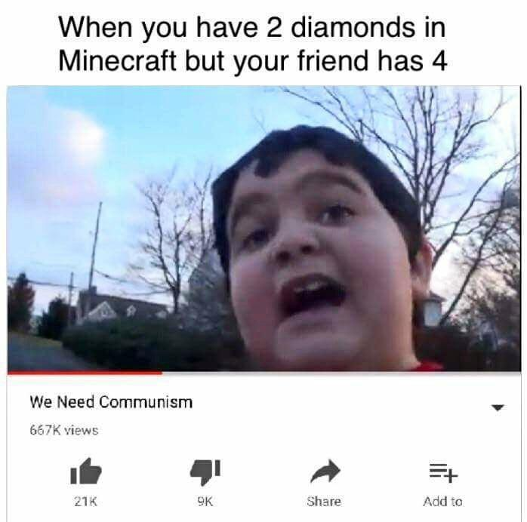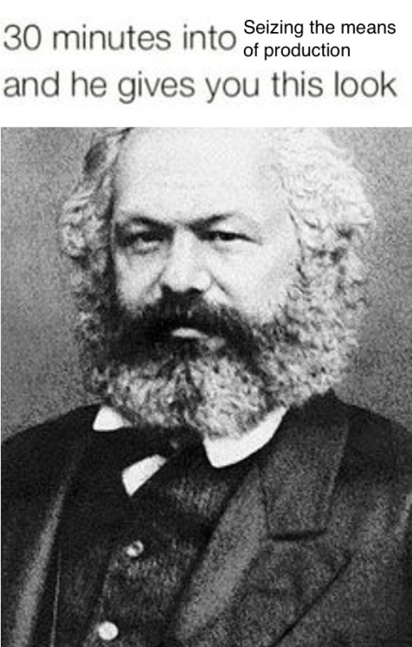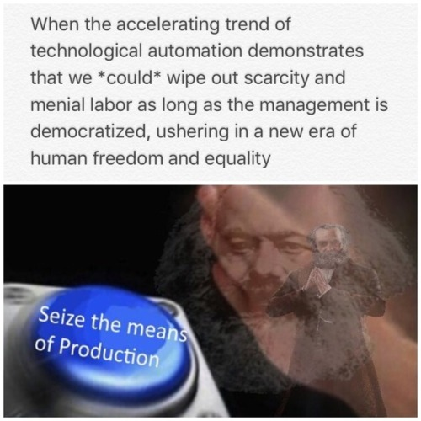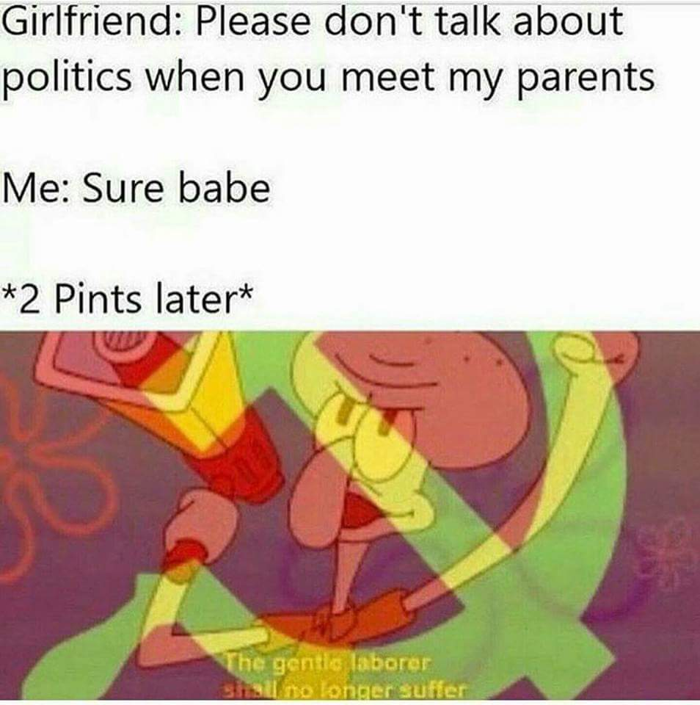

**Bonuses (Boni?)**

1. Uh oh you friccin moron, you just got a quiz bowl Tossup right. For ten points each,
   1. “Uh oh you friccin moron” is the tagline of this meme that encourages you to tag your friends so that they can also experience this meme.
      1. You just got **Beaned**!
   2. Getting beaned often involves this beanish character who wears white gloves and blue and yellow shoes. Yes, the character actually has a name.
      1. **Green de la Bean**
   3. Getting beaned is just another variation on wasting someone’s time on the internet, not unlike linking someone to this Rick Astley song on Youtube.
      1. ***Never Gonna Give You Up*** [DO NOT ACCEPT RICKROLL YOU FRICCIN MORON]
2. In the late 1990s, the Chinese-American stuntman Michael Chaturantabut [Cha-too-rahn-tah-boot] created the Xtreme Martial Arts practice, which combines martial arts, acrobatics and gymnastics. For ten points each,
   1. The practice is known as this. It involves incorporating various dance styles and gymnastic moves.
      1. **Tricking**
   2. Tricking is defined as “a kind of extreme sport where the "athletes" do cool, fast, beautiful flips and kicks without any wires or trampolines “ by this website. The website also has definitions for various things like “DudeBro”, “Moobs” and “Alabama Hotpocket”
      1. **Urban Dictionary**
   3. The channel “My Town Adelaide” popularized tricking in its video of people doing stunts. In the video, various people would jump off one of these objects buried in the sand.
      1. **Yoga Ball** [Accept similar things like exercise ball]
3. One of the biggest boxers of our day and age recently won his fiftieth matchup without a single loss. For ten points each,
   1. This boxer faced off against and beat mixed Martial Artist Conor McGregor in August 2017.
      1. Floyd “Money” **Mayweather**
   2. Many people, including rapper 50 [FITTY] Cent stipulate that Mayweather is unable to do this otherwise simple task.
      1. **Can’t read** [Roll with the punches and accept similar answers about him not being able to read]
   3. 50 [FITTY] Cent attempted to prove that Floyd Mayweather can’t read by challenging him to read a single page of this popular fantasy book saga.
      1. ***Harry Potter***
4. In 2017, a sequel to a new Nintendo IP was released on the Nintendo Switch. For ten points each,
   1. Name this game, the second game in a third-person shooter series about creatures called “Inklings” who use ink to have turf wars.
      1. ***Splatoon 2***
   2. These two hostess inklings replaced Callie and Marie from the previous game, and give the player updates on various maps available for play. Name both of them.
      1. **Marina** and **Pearl**
   3. In *Splatoon 2*’s overworld, various inklings are able to say user created messages. These messages have been overrun by these individuals who prefer to identify as anthropomorphic animals.
      1. **Furries**
5. Memes that take the form of music are very common, and often quite entertaining, if not trippy and psychedelic. For ten points each,
   1. One of the most common forms of music-based memes comes in the form of this musical genre, which often involves slowing down and lowering the pitch of a song. It is also commonly associated with the word “aesthetic”.
      1. **ＶＡＰＯＲＷＡＶＥ** [If they speak in a slowed & pitched down voice, give +0.0000...1 points]
   2. The Vaporwave “anthem” is this song, a slowed down version of Diana Ross’ “It’s Your Move”.
      1. **Macintosh Plus** [ignore the Japanese characters, though smile knowingly if they add “Risa Firanku 420, Gendai no Conpyuu” to the end of the question]
   3. Another, less popular version of altering music for memes is this style of music that does the reverse of Vaporwave, which speeds up the song and pitches up the tunes. These videos are often accompanied with weird pictures of Anime girls
      1. **Nightcore**
6. Some people don’t really like memes. They’re kind of weird if you think about it. For ten points each,
   1. Name the sometimes derogatory term that meme-sters use to refer to those in the mainstream. Sometimes they’re told to “get out” .
      1. **Normie**s
   2. One of the earliest example of the term “normie” being used was by Stephanie Brown in her book subtitled: “*A Developmental Model of Recovery*”, that details how to treat this condition. Rick Sanchez has this condition.
      1. **Alcoholism** [Accept **Alcoholic**s]
   3. This frog character is often associated with screaming *[MOD NOTE: You better read this next part at the top of your lungs*] “NORMIES GET OUT REEEEEEEEE”.
      1. **Pepe** the Frog
7. He describes his work as "based", a term which denotes a lifestyle of positivity and tolerance. For ten points each,
   1. Name this rapper, born Brandon Christopher McCartney who has released tracks like “Wonton Soup”, and “I’m Gay (I’m Happy)”.
      1. **Lil’B** [Prompt on Based God]
   2. Lil’B has been known to create some very interesting beats from random sources, including the Besaid Island theme from this game. This game follows the protagonist Titus, and his journey in the world of Spira
      1. **Final Fantasy X** or **Final Fantasy 10** [Prompt on Final Fantasy, do not accept any number other than 10]
   3. Lil’B has also featured on of his pets on one of his strangest tracks to date. That pet, Keke [Key-key], is one of these animals.
      1. Tabby **Cat** [SAY SOMETHING KEKE]
8. And here you thought that the final question of the previous bonus would mean there wouldn’t be any more cat memes. Lol think again. For ten points each,
   1. Cats on the internet have taken a very important niche, as popularized by this meme website that includes sub-blogs like Failblog and Memebase
      1. **I Can Haz Cheezburger**
   2. In addition to cat image macros, cat videos are also very important and provide lots of fun entertainment, like this cat video that features a cat in a shirt playing an electronic piano.
      1. **Keyboard Cat**
   3. In another funny cat video, one cat attempts to jump but fails miserably while this song by AWOLNation plays. This song was on another meme-y internet video with Billy Mays being excited to find people selling things in their yard.
      1. **Sail**
9. Barbie has been known to have a wide variety of jobs in order to empower young girls. For ten points each,
   1. One of Barbie’s most controversial job outings was when she became this profession, a kind of engineer
      1. **Computer** Engineer
   2. In “*Barbie: I Can Be A Computer Engineer*” Barbie must create one of these kinds of things. *Spy Fox: Dry Cereal* and *Putt Putt Saves the Zoo* are examples of this.
      1. **Computer Game** [prompt on Video Game]
   3. “*Barbie: I Can Be A Computer Engineer*” drew controversy for Barbie choosing this solution to fixing a virus she got while developing her computer game.
      1. **Getting two boys fix it** and then taking credit for it herself. [Accept similar responses, description acceptable.]
10. Let’s make this even more of a competition. If you can find the common thread between these questions, you win! For ten points, name:
    1. This gaming webcomic by Tim Buckley developed the overly dramatic and wordless 4-panel comic titled “Loss” about a miscarriage.
       1. **Ctrl+Alt+Del** [Control Alt Delete]
    2. This never-ending competition that is most prevalent in elementary schools and can be lost by the mere action of thinking about its concept, and you will have lost by answering this question correctly.
       1. **The Game**
    3. This phrase was shouted originally from a countertop in a restaurant in Keller, Texas by a person costumed as the restaurant chain’s mascot. It incorporates a reference to the chain’s habit of placing the first syllable of its name at the beginning of its products, and its yelling is closely followed by the costumed man pouring a beverage over his head and shouting “GET OUT OF YO MIND.”
       1. **“LET'S MCFREAKIN LOSE IT.”** [You may not award extra points if the answer is shrilly screamed, but you should solemnly nod at the competitor in approval of their true understanding of the spirit of the original video]
11. Seems like it crept up out of nowhere, all around you, it's not quite what you foretold. For ten points each,
    1. The chorus to “Last Surprise” ,the battle theme of this game, then says that “You’ll Never see it Com-ing!”. In this game, you play as a high school student who creates a group of vigilantes known as the Phantom Thieves
       1. **Persona 5** [Do not accept Personas 1-4]
    2. One cast member in Persona 5, Morgana the Cat, has the ability to do this while the party explores the metaverse. This ability may or may not be a reference to one of the creatures in the film “My Neighbor Totoro”
       1. **Turn into a Bus** or **CatBus** [Accept anything similar or close to the answer, prompt on turning into a car]
    3. Persona 5 continues the trend of being able to romance various girls and women. However, in Persona 5 you can have a risqué romance with Sadayo Kawakami, who has this relation to the protagonist. This kind of relationship is outlined in *Velvet Revolver*’s song “*Just Sixteen*”.
       1. Homeroom **Teacher** [Accept **Teacher/Student Relationship**]
12. Political candidates often promise a lot of things with some offering more realistic promises than others, but for ten points each,
    1. Identify this impossible feat. It is an expression used in tongue-in-cheek endorsements, that promises to have politically elected officials make Japanese animated characters exist in our world.
       1. **Make Anime Real** Again
    2. This Texas Libertarian was a presidential candidate in 2012, who many people associated the phrase “will make anime real”.
       1. **Ron Paul** [do not accept Rand Paul, prompt on partial name. Phrase is “Ron Paul will make Anime Real]
    3. Unfortunately for some, anime will never be real, which is something you can tell Undyne in this game, which is set below Mt. Ebott.
       1. **Undertale**
13. Survivor is a TV show that one of the authors of this packet is obsessed with, and so, naturally, there will be a bonus on it. For ten points each,
    1. One of the most prevalent memes in the *Survivor* community came from Ciera Eastin, who initially appeared on this season. This season of *Survivor* was the first to pit *Survivor* contestants against their loved ones and its title is named after a common saying about the bond strengths of family versus friends.
       1. **Blood Vs. Water** [Prompt on Season 27 don’t accept Water Vs. Blood]
    2. Eastin’s action, which impacted Laura Morett, prompted this meme to exist in the *Survivor* community. Name Eastin’s action.
       1. **She voted out her mom** [accept similarities and description]
    3. Eastin later returned for two more seasons of *Survivor* where she took 10th and 20th place. Name either one she appeared in.
       1. **Cambodia**: **Second Chances** or **Game Changers** [With the accept either Cambodia or Second Chances]
14. Jim Henson’s legacy was one for the ages as he created a character beloved by the meme community. For ten points each,
    1. Henson created “*The Muppet Show*”, that is hosted by this green frog. This character also sang the heart-warming song, “It’s Not Easy Being Green”.
       1. **Kermit** the Frog
    2. Kermit the Frog has been used in various memes that involve him drinking Lipton Tea, stating a controversial observation and saying this line about how it isn’t his place to discuss said observation.
       1. “**But that’s None of My Business** tho”
    3. Kermit the Frog also appeared in a meme known as Evil Kermit, where conflicting actions arise. The evil Kermit is this character, Kermit’s evil look-alike and the main antagonist of the 2014 flick *Muppets Most Wanted*.
       1. **Constantine**
15. There are plenty of subreddits that one might not really ever expect to exist with various strange forms of memes. Here’s a bonus on them. For ten points each,
    1. One strange subreddit is devoted to the hatred of this character, the once bedridden old man who accompanies Charlie Bucket to a chocolate factory.
       1. **Grandpa Joe**
    2. This terribly designed subreddit has various pictures of Andy Samberg as well as repeated use of the phrase “Oh man I am not good with computer plz to help”.
       1. /r/**Ooer** [Ooo-er]
    3. This subreddit’s name reflects the content of all the images in this subreddit. The images in particular in this subreddit involve adding human appendages to avian creatures.
       1. /r/**BirdsWithArms**
16. The internet has a way of popularizing some strange things through memes, including TV shows for little girls. The editor of this packet has dubbed this a “bronus.” For ten points each,
    1. Identify this animated TV series that follows Twilight Sparkle’s adventures in Equestria
       1. ***My Little Pony: Friendship is Magic*** [Prompt on My Little Pony]
    2. My Little Pony: Friendship is Magic was developed by this woman, the wife of Craig McCracken. She has also worked on projects such as *The Powerpuff Girls* and *Foster’s Home for Imaginary Friends*
       1. Lauren **Faust**
    3. In the premier of the second season of *My Little Pony: Friendship is Magic*, a chaotic being known as Discord, played by this man, is awakened. This man also played the puckish character Q on *Star Trek: The Next Generation*
       1. John **De Lancie**
17. Typing things out can be tedious. We would know, we typed this whole packet. But copying and pasting can be convenient, especially if it’s a long, nonsensical, or annoying block of text you can send to your friends. For ten points each, give the next line of each of these Copypasta texts: **[*MOD NOTE: warning for explicit language, fuck can be replaced with “Frick” if there are adults around. Unless of course the people playing are adults, then carry on.*]**
    1. “What the fuck did you just fucking say about me, you little bitch?”
       1. I’ll have you know **I graduated** **top of my class** in the **Navy Seals**, and I’ve been involved in numerous secret raids on Al-Qaeda, and I have over 300 confirmed kills. [exact wording is not necessary, as long as it contains all of the underlined parts in order]
    2. “According to all known laws of aviation, there is no way that a bee should be able to fly. Its wings are too small to get its fat little body off the ground.”
       1. **The bee, of course, flies anyway.** Because bees don’t care what humans think is impossible. [again, inexact wording can be accepted so long as you deem it suitably close to the quote]
    3. “I was only 9 years old. I loved Shrek so much, I had all the merchandise and movies. I pray to Shrek every night before bed, thanking him for the life I’ve been given.”
       1. **“Shrek is love**" I say; **“Shrek is life”** [This one should be exact]
18. Some things from our childhoods come back to haunt us, like dumb photos, or the furby that you thought you got rid of. For ten points each, name these memes that have risen from the graves of adolescence to become relevant again.
    1. This hieroglyph of our elementary years is a simple design made up of 14 straight lines, and began with six, in two rows of three vertical lines. You may draw it in lieu of an actual answer.
       1. **S**, **Super S**, **Stussy,** or **Super S Stussy**
    2. The recent revival of this game has lead to various improbable positions and acrobatics to avoid touching the ground. Memes involving this game often involve the avoidance of something unpleasant including homework, chores, and the Maginot Line.
       1. **The Floor is Lava** [prompt on The Floor Is…]
    3. Though it only hails from the distant year of 2009, this opening lyric from an Owl City song has been brought back and parodied with vigor, often replacing a body part at the end of the first line, and rhyming it in the second
       1. **You would not believe your** eyes [do not accept the title of the song Fireflies by itself.]
19. Sometimes, the leader of the equalists needs a break from his terrorism to do something much more light-hearted. For ten points each,
    1. Name this meme, a 3 panel image-still of a masked man telling corny jokes at a rally. The man in this meme is also able to remove a person’s bending via a skill called bloodbending
       1. **Comedian Amon** [accept **Stand-up Amon** or variations]
    2. Amon is the main antagonist of the first season of this series, a more mature spin-off of *Avatar: The Last Airbender*.
       1. *Avatar: The* ***Legend of Korra***
    3. Avatar: The Legend of Korra’s third season featured the villainous airbender Zaheer, who, after losing the woman he loved, gained the ability to do this.
       1. **Levitate** or **Fly** [Accept various other answers about flying]
20. Wow, you made it to the final bonus! Congrats! That means that you’ve answered every single one of the questions in this packet. To celebrate, here are a few assorted questions we wanted to include somewhere in the packet, but had trouble doing so. Consider this assorted unsorted meme trash. For ten points each,
    1. This fake word may signal a satire on self-proclaimed intellectual superiority. The word itself rose to meme status when teens joked about how they couldn’t differentiate the situations from when to use who and whom.
       1. **Whomst** or **Whomst’d** or **Whomst’d’ve** [accept anything that sounds remotely close]
    2. This long list of videos, featured on Youtube contains over 309 videos like “*Yee”*, and *“this man moaned at least this loud”* and was created by user eljolto
       1. **Important Videos** Playlist
    3. And finally, this is one of the oldest recorded memes in existence. To create this meme, one must draw a circular head with a big droopy nose and fingers poking up from behind a wall and write the phase that is associated with this meme.
       1. **Kilroy was here**